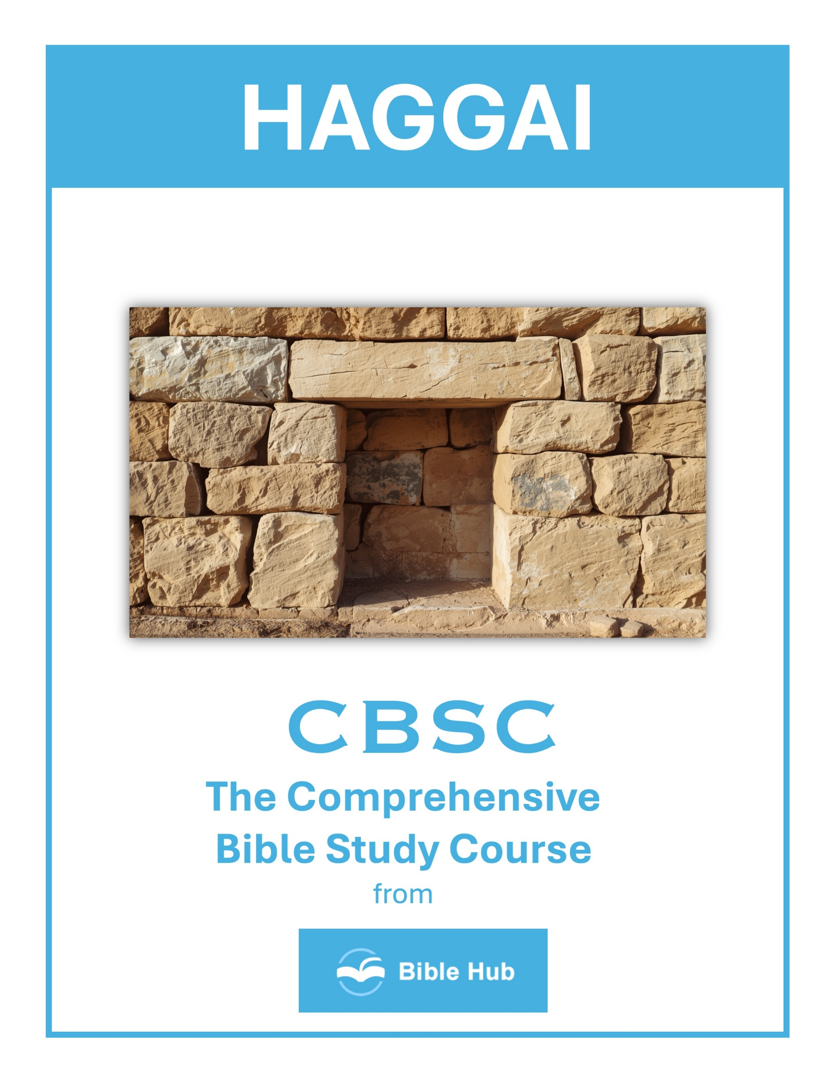

Haggai 1 Teaching Points and Bible Study Questions
Prioritize God's House
In Haggai 1:4, the prophet questions, "Is it a time for you yourselves to dwell in your paneled houses, while this house lies in ruins?" This verse reminds us to prioritize our spiritual commitments over personal comforts. Just as the Israelites were called to rebuild the temple, we are encouraged to focus on nurturing our relationship with God and serving His purposes first. When we put God at the center, everything else falls into place.
1. How can you prioritize God's work in your daily schedule amidst personal responsibilities?
2. Why do you think neglecting spiritual commitments affects personal fulfillment and satisfaction?
3. What practical steps can you take to ensure God's house is a priority in your community?
Consider Your Ways
Haggai 1:5-7 urges, "Now this is what the LORD of Hosts says: 'Consider your ways. You have planted much but harvested little.'" This is a call to self-reflection. Are our efforts aligned with God's will? When we find ourselves working hard but seeing little fruit, it might be time to reassess our priorities and ensure they align with God's plans for us.
1. How can you prioritize God's work over personal ambitions in your daily life?
2. Why do you think reflecting on your actions is crucial for spiritual growth?
3. What changes can you make to align your lifestyle with God's purposes?

The Importance of Obedience
The Israelites' delay in rebuilding the temple was a result of disobedience. Haggai 1:12 shows their change of heart: "Then Zerubbabel... and the whole remnant of the people obeyed the voice of the LORD their God." Obedience to God brings blessings and fulfillment. When we listen and act according to His word, we open ourselves to His guidance and provision.
1. How can you prioritize God's work in your life amidst daily distractions and responsibilities?
2. Why do you think obedience to God leads to fulfillment and blessings in your life?
3. What steps can you take to ensure your actions align with God's will consistently?
God’s Presence Brings Courage
In Haggai 1:13, God reassures His people, "I am with you, declares the LORD." This promise of His presence is a source of courage and strength. No matter the challenges we face, knowing that God is with us empowers us to move forward with confidence and faith.
1. How can you seek God's presence to gain courage in facing personal challenges today?
2. Why do you think God's presence is essential for overcoming fear in difficult situations?
3. What practical steps can you take to invite God's presence into your daily life for courage?

The Call to Action
Haggai 1:8 commands, "Go up into the mountains, bring down timber, and build the house." This is a direct call to action. Faith is not passive; it requires us to step out and do the work God has set before us. When we take action, we participate in God's plan and witness His power at work in our lives.
1. How can you prioritize God's work in your daily life amidst personal responsibilities?
2. Why do you think God emphasizes rebuilding the temple before personal comfort?
3. What actions can you take to ensure your efforts align with God's purpose?
The Consequences of Neglect
The Israelites experienced scarcity because they neglected God's house. Haggai 1:9 states, "You expected much, but behold, it amounted to little." This serves as a reminder that neglecting our spiritual duties can lead to unfulfilled expectations. When we focus on God, He provides abundantly.
1. How can neglecting spiritual priorities impact your personal and professional life today?
2. Why do you think people often prioritize material pursuits over spiritual growth?
3. What steps can you take to avoid the consequences of neglecting your spiritual responsibilities?

God’s Discipline is Redemptive
Haggai 1:10-11 explains how God withheld blessings to redirect His people: "Therefore, because of you, the heavens have withheld their dew and the earth its crops." God's discipline is not punitive but redemptive, guiding us back to Him. It’s a loving correction meant to restore our focus and commitment.
1. How can recognizing God's discipline in your life lead to personal growth and transformation?
2. Why do you think God uses discipline as a tool for redemption and restoration?
3. What steps can you take to align your priorities with God's purpose during times of discipline?
The Power of Unity
The people of Israel came together to rebuild the temple, as seen in Haggai 1:14: "They came and began work on the house of the LORD Almighty, their God." Unity in purpose and action is powerful. When we join together in faith and mission, we can accomplish great things for God's kingdom.
1. How can unity in your community help prioritize collective goals over individual interests, as seen in Haggai 1?
2. Why do you think unified action was crucial for rebuilding the temple, and how can this apply today?
3. What can you do to foster unity in your group to achieve a common purpose effectively?

God’s Timing is Perfect
The rebuilding of the temple happened in God’s perfect timing. Haggai 1:15 notes the specific date they began the work. This reminds us that God’s timing is always right. Trusting in His schedule, rather than our own, ensures that we are in sync with His divine plan.
1. How can you align your priorities with God's timing in your daily life?
2. Why do you think God's timing might differ from your personal plans or expectations?
3. What steps can you take to trust God's timing during uncertain situations?
Renewed Zeal for God’s Work
The book of Haggai ends with a renewed zeal among the people. Their hearts were stirred, and they were eager to do God’s work. This enthusiasm is contagious and inspiring. When we are passionate about serving God, it not only transforms our lives but also influences those around us, drawing them closer to Him.
1. How can you prioritize God's work in your daily life amidst personal responsibilities and distractions?
2. Why do you think people often delay spiritual commitments, and how can you overcome this tendency?
3. What practical steps can you take to renew your zeal for God's work in your community?

Haggai 2 Teaching Points and Bible Study Questions
Prioritize God's House
In Haggai 2, the Lord encourages the people to rebuild the temple, emphasizing the importance of prioritizing His dwelling place. "The glory of this latter house shall be greater than of the former, saith the LORD of hosts" (Haggai 2:9). This teaches us to put God first in our lives, ensuring that our spiritual commitments are at the forefront of our daily routines. When we prioritize God, everything else falls into place.
1. How can you prioritize God's work in your daily schedule amidst other commitments?
2. What do you hope to achieve by dedicating time to serve in your church community?
3. Why does prioritizing God's house impact your personal and spiritual growth?
Be Strong and Work
The Lord commands, "Be strong, all you people of the land, declares the LORD. Work, for I am with you" (Haggai 2:4). This is a call to action, reminding us that strength and diligence in our tasks are essential. With God by our side, we can tackle any challenge with confidence and vigor, knowing that our efforts are not in vain.
1. How can you find strength to persevere in your work when facing discouragement or setbacks?
2. Why do you think God emphasizes being strong and working despite challenges?
3. What practical steps can you take to remain committed to your tasks when motivation wanes?

God's Presence Brings Peace
Haggai 2:5 reassures us, "My Spirit remains among you; do not fear." The presence of God is a source of peace and comfort. In our busy lives, it's easy to become overwhelmed, but remembering that God is with us can bring a sense of calm and assurance, allowing us to face each day with tranquility.
1. How can you actively seek God's presence to bring peace in your daily challenges?
2. Why do you think God's presence is essential for experiencing true peace in your life?
3. What practical steps can you take to invite God's peace into your home and relationships?
Future Glory Surpasses the Past
The promise that "the glory of this latter house shall be greater than of the former" (Haggai 2:9) is a reminder that God has greater things in store for us. Our past achievements or failures do not define our future. With faith, we can look forward to the new and greater things God has planned.
1. How can you find hope in future promises when current circumstances seem discouraging?
2. What do you hope to see in your community that reflects future glory surpassing the past?
3. Why do you think focusing on future glory can motivate present actions and decisions?

Holiness Requires Intentionality
Haggai 2:12-13 illustrates that holiness is not automatically transferred; it requires intentional effort. Just as the people were reminded that touching something holy does not make one holy, we must actively pursue righteousness in our lives. This involves making conscious choices that align with God's will.
1. How can you intentionally incorporate holiness into your daily routines and decision-making processes?
2. Why do you think intentionality is crucial in maintaining a holy lifestyle amidst daily distractions?
3. What practical steps can you take to prioritize holiness in your relationships and interactions?
Consider Your Ways
The Lord repeatedly tells the people to "consider" their ways (Haggai 2:15). This is a call for self-reflection and evaluation. In our fast-paced lives, taking time to assess our actions and their alignment with God's purpose is crucial for spiritual growth and effective living.
1. How can you prioritize God's work in your life amidst daily distractions and responsibilities?
2. What do you hope to achieve by aligning your actions with God's purpose for you?
3. Why does reflecting on past actions help in making better decisions for the future?

God's Blessings Follow Obedience
Haggai 2:19 promises, "From this day on I will bless you." This underscores the principle that obedience to God leads to blessings. When we align our actions with His commands, we open the door to His abundant blessings in our lives, both spiritually and materially.
1. How can you actively align your actions with God's will to receive His blessings today?
2. Why do you think obedience to God often leads to unexpected blessings in your life?
3. What practical steps can you take to ensure your decisions reflect obedience to God's guidance?
God Shakes the Nations
The prophecy that God will "shake the heavens and the earth" (Haggai 2:21) reminds us of His sovereign power over all creation. In times of uncertainty, we can trust that God is in control, orchestrating events for His ultimate purpose and our good.
1. How can you recognize and respond to God's shaking in your life today?
2. What do you hope to see transformed in your community when God shakes the nations?
3. Why does trusting God's plan during uncertain times strengthen your faith?

Zerubbabel as a Signet Ring
God's declaration to make Zerubbabel "like a signet ring" (Haggai 2:23) signifies His chosen leadership and authority. This teaches us that God appoints leaders for His purposes, and we should respect and support those He places in positions of authority.
1. How can you see God's promises reflected in your life, like Zerubbabel as a signet ring?
2. Why do you think God chose Zerubbabel as a symbol of authority and commitment?
3. What can you do to become a symbol of God's presence and purpose in your community?
God's Covenant is Unchanging
Throughout Haggai 2, the Lord's promises reflect His unchanging covenant with His people. "I covenanted with you when you came out of Egypt" (Haggai 2:5) serves as a reminder that God's promises are steadfast. We can rely on His faithfulness, knowing that He will fulfill His word in our lives.
1. How can you trust God's unchanging covenant in times of personal uncertainty or change?
2. Why do you think God's unchanging promises are important for community strength and unity?
3. What practical steps can you take to remind yourself of God's steadfast covenant daily?

